Chemical Bonds
Memorandum

Question 1:

  - A.
  - C.
  - C.
  - A.
  - A.

Question 2:

2.1) It is the forming between two atoms if both electrons in the shared electron pair is donated by only one of the two atoms.
2.2)

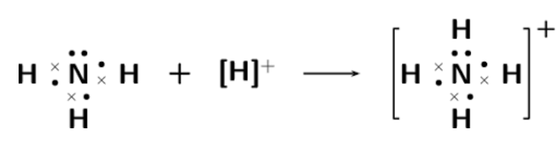

2.3)
Na

+
Cl

Na

Cl

Question 3:

3.1) There are polar covalent bonds between the Hydrogen ion and the Nitrogen ion.

3.2)
Mg

+
O

Mg

O

3.3)

1s2
2s2
2p2

C
H
H
H
H

3.4)

